Delete ISO

# Overview

Delete ISO fetches ISO Details saved as a configuration element and deletes the desired ISO from the list. Through this one can change the existing ISOs data.

# Goal

It is prepared to achieve automated deletion of existing ISOs which earlier was being done manually.

# Solution/Logic Design

Fetch ISO Details

ResourceConfiISOFile(Configuration Element)

Execute actions “getISONames”,”getISODescription”,”getISOPath”

Fetch array of ISO names, their corresponding Description, Path value

Remove the selected ISO entry. Also remove the Name from Array of ISO Names

end

Updated the ISO Details

# Properties

* ISO name – Name of the ISO
* ISO Path – Path of the ISO
* ISO Description – description of the ISO

Dependencies

# Related Actions

* getISOkeys – It fetches the array of ISO names and provides as a drop down.
* getISOValues – It fetches path value corresponding to any ISO name.
* getISODescription – It fetches description corresponding to any ISO name.

# Related Workflows

Not Applicable

# Related Configuration Elements

* ResourceConfISOFile – Configuration element which contains ISO Details from which data needs to be modified, updated or deleted.

# Attributes

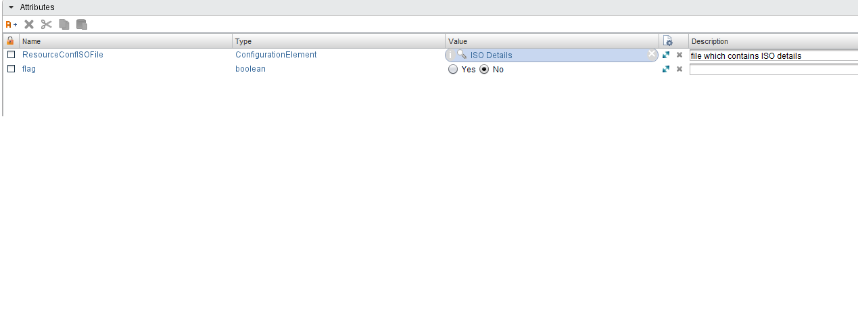

# Inputs

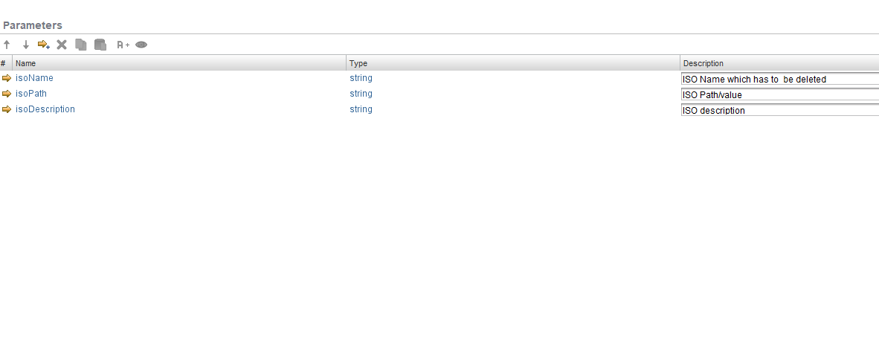

# Future Scope

It can be extended to:

* ISO details can be in different modes like a CSV file, Text file etc. .